K.R. Mangalam University
School of Engineering & Technology

Fundamentals Of Java Programming Lab
(ENCA203) Assignment 2
Student Management System
Submitted by:
Name: Khushi
Roll No: 2401201102
Course: BCA (AI & DS)
Section: B

Structure of the files:
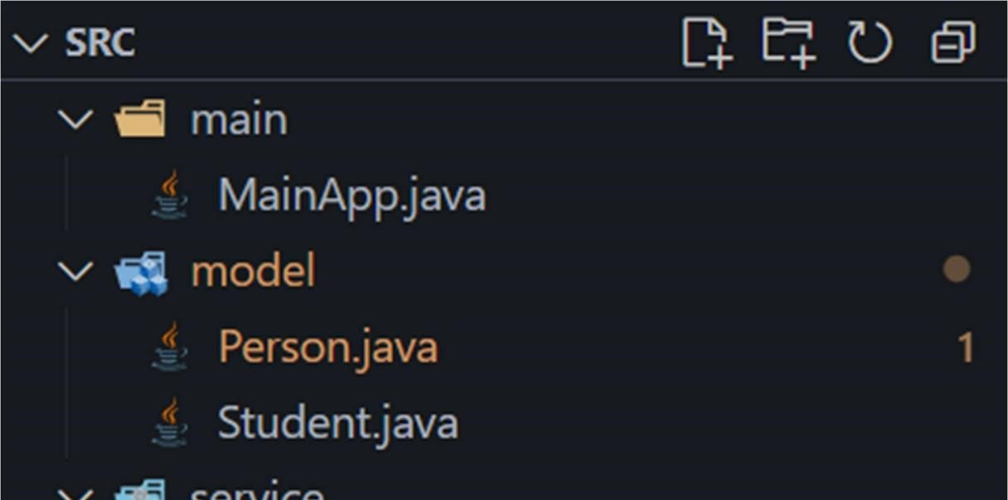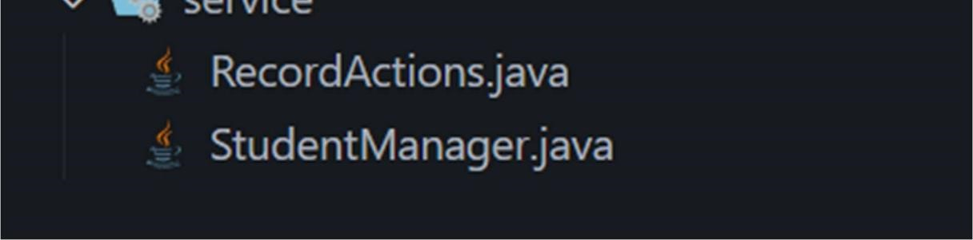

SRC/MainApp.java:
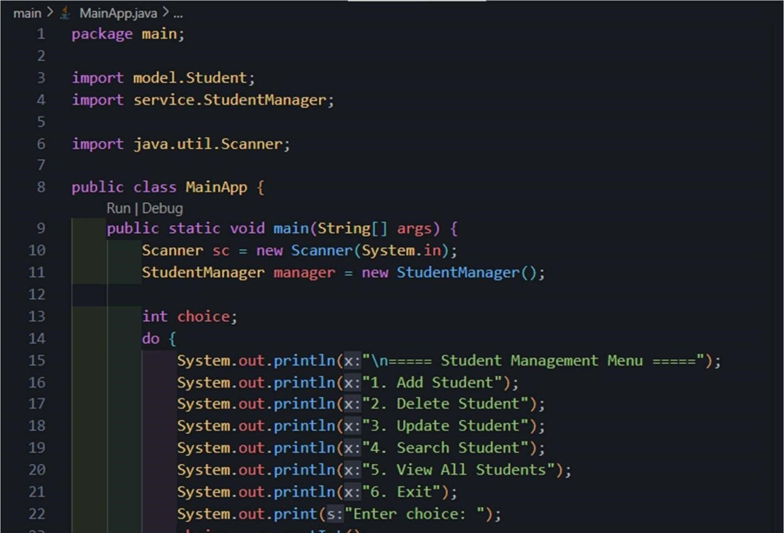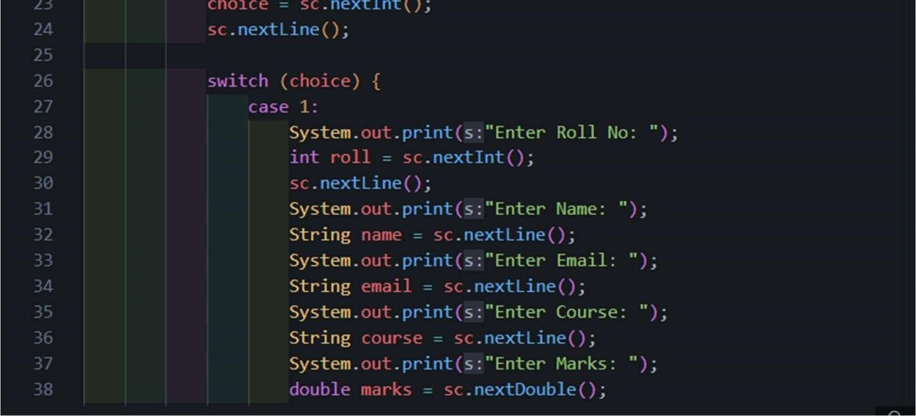
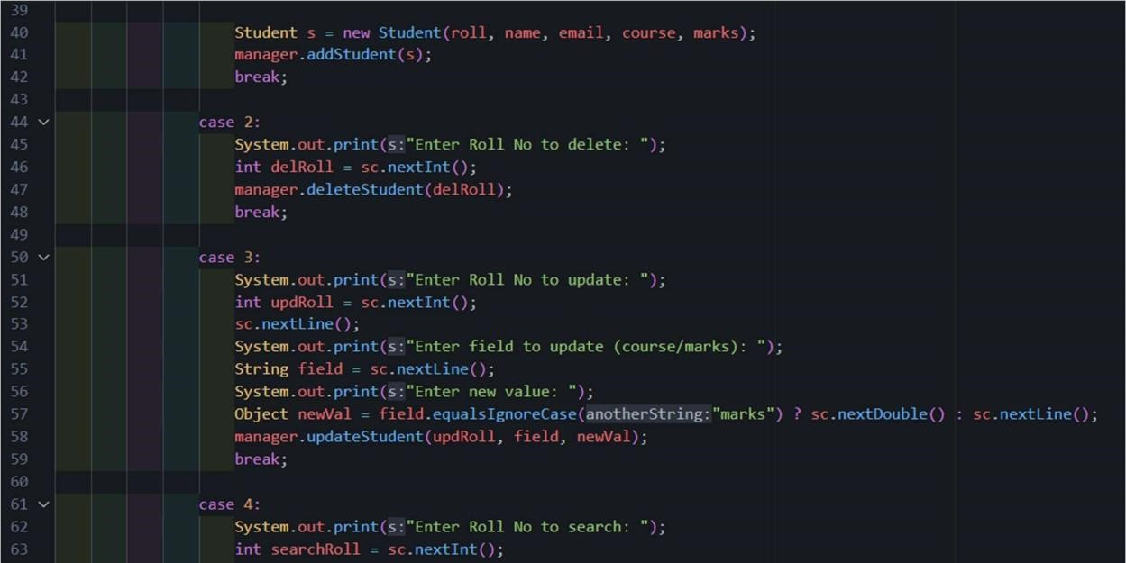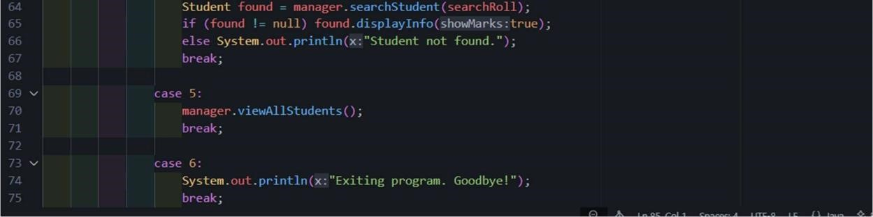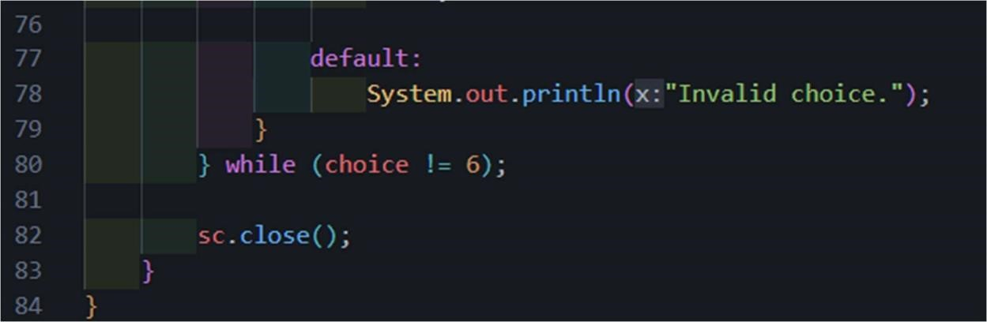

Code:
package main;

import model.Student; import service.StudentManager;

import java.util.Scanner;

public class MainApp { public static void main(String[] args) {
Scanner sc = new Scanner(System.in);
StudentManager manager = new StudentManager();

int choice;
do {
System.out.println("\n===== Student Management Menu =====");
System.out.println("1. Add Student");
System.out.println("2. Delete Student");
System.out.println("3. Update Student");
System.out.println("4. Search Student");
System.out.println("5. View All Students");
System.out.println("6. Exit"); System.out.print("Enter choice: "); choice = sc.nextInt(); sc.nextLine();

switch (choice)
{ case 1:
System.out.print("Enter Roll No: "); int roll = sc.nextInt();
sc.nextLine();
System.out.print("Enter Name: ");
String name = sc.nextLine();
System.out.print("Enter Email: ");
String email = sc.nextLine();
System.out.print("Enter Course: ");
String course = sc.nextLine(); System.out.print("Enter Marks: "); double marks = sc.nextDouble();

Student s = new Student(roll, name, email, course, marks); manager.addStudent(s); break;
case
2:
System.out.print("Enter Roll No to delete: ");
int delRoll = sc.nextInt();
manager.deleteStudent(delRoll);
break; case
3:
System.out.print("Enter Roll No to update: "); int updRoll = sc.nextInt(); sc.nextLine();
System.out.print("Enter field to update (course/marks): ");
String field = sc.nextLine();
System.out.print("Enter new value: ");
Object newVal = field.equalsIgnoreCase("marks") ? sc.nextDouble() : sc.nextLine(); manager.updateStudent(updRoll, field, newVal);
break; case
4:
System.out.print("Enter Roll No to search: ");
int searchRoll = sc.nextInt();
Student found = manager.searchStudent(searchRoll); if (found != null) found.displayInfo(true); else System.out.println("Student not found.");
break; case
5:
manager.viewAllStudents();
break; case
6:
System.out.println("Exiting program. Goodbye!");
break;

default:
System.out.println("Invalid choice.");
}
} while (choice != 6);

sc.close();
}
}

SRC/model/Person.java:
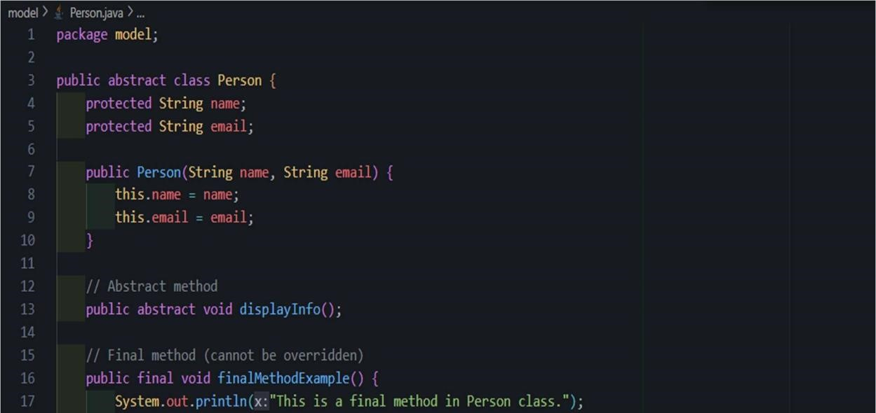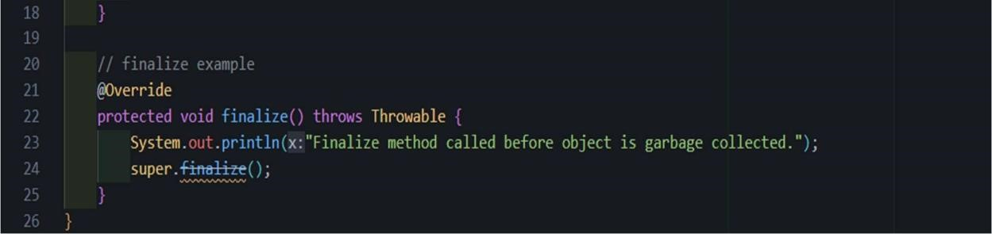

Code:
package model;

public abstract class Person { protected String name; protected String email;

public Person(String name, String email) { this.name = name; this.email = email;
}

// Abstract method public abstract void displayInfo();

// Final method (cannot be overridden) public final void finalMethodExample() {
System.out.println("This is a final method in Person class.");
}

// finalize example @Override protected void finalize() throws Throwable {
System.out.println("Finalize method called before object is garbage collected."); super.finalize();
}
}

SRC/model/Student.java:
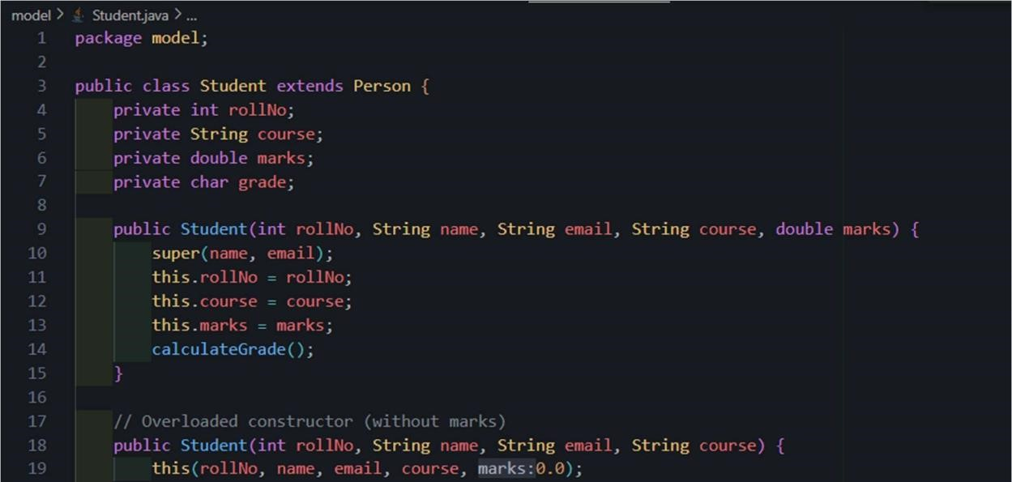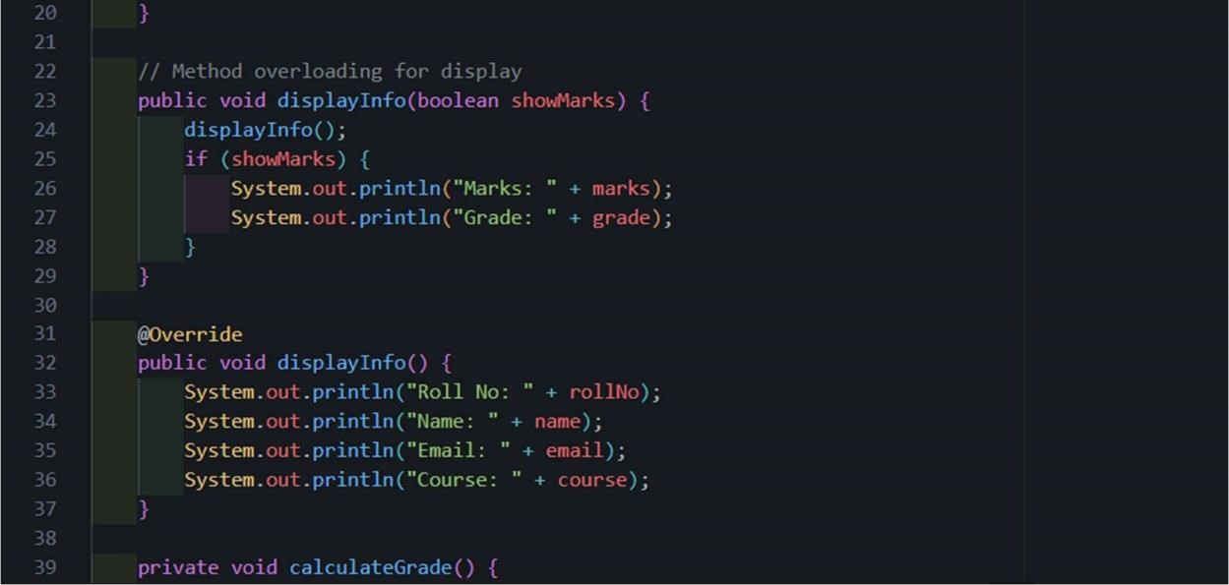

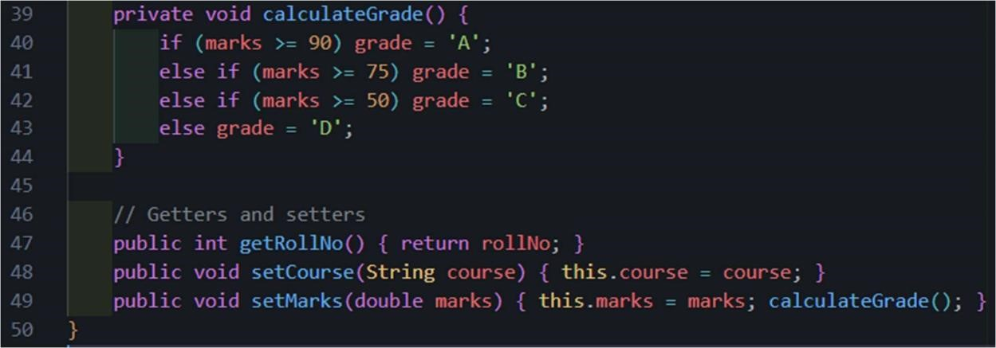

Code:
package model;

public class Student extends Person
{ private int rollNo; private
String course; private double marks; private char grade;

public Student(int rollNo, String name, String email, String course, double marks) { super(name, email); this.rollNo = rollNo; this.course = course; this.marks = marks; calculateGrade();
}

// Overloaded constructor (without marks) public Student(int rollNo, String name, String email, String course) { this(rollNo, name, email, course, 0.0);
}

// Method overloading for display public void displayInfo(boolean showMarks) {
displayInfo();
if (showMarks) {
System.out.println("Marks: " + marks);
System.out.println("Grade: " + grade);
}
}

@Override public void displayInfo() {
System.out.println("Roll No: " + rollNo);
System.out.println("Name: " + name);
System.out.println("Email: " + email);
System.out.println("Course: " + course);
}

private void calculateGrade()
{ if (marks >= 90) grade = 'A'; else if (marks >= 75) grade = 'B'; else if (marks >= 50) grade = 'C'; else grade = 'D';
}

// Getters and setters public int getRollNo() { return rollNo; } public void setCourse(String course) { this.course = course; } public void setMarks(double marks) { this.marks = marks; calculateGrade(); } }

SRC/service/RecordActions.java:
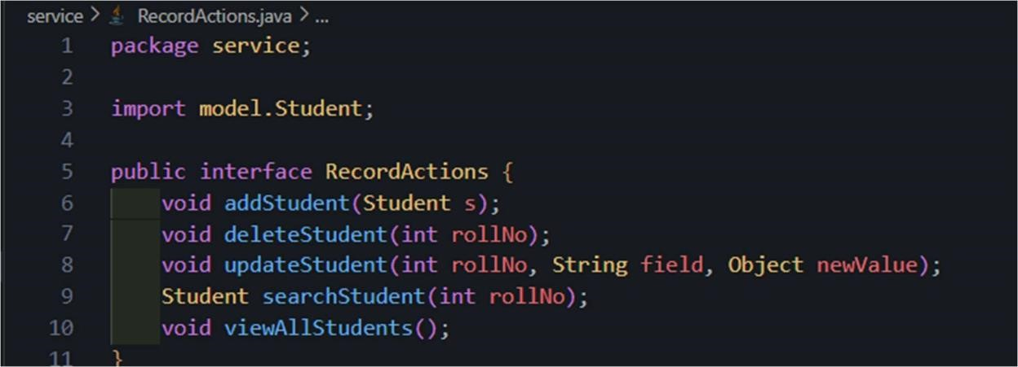

Code:
package service;

import model.Student;

public interface RecordActions { void addStudent(Student s); void deleteStudent(int rollNo); void updateStudent(int rollNo, String field, Object newValue); Student searchStudent(int rollNo); void viewAllStudents();
}

SRC/service/StudentManager.java:
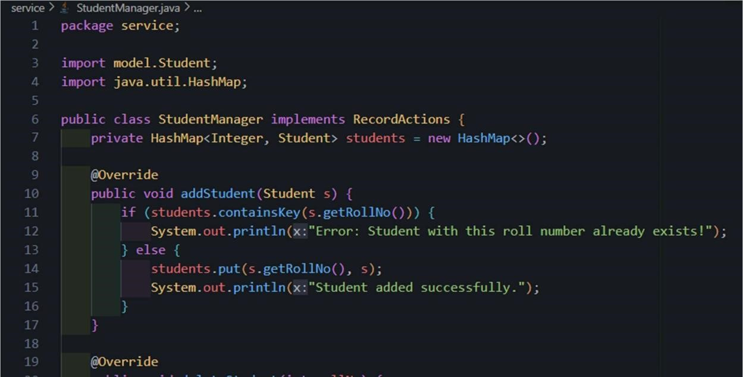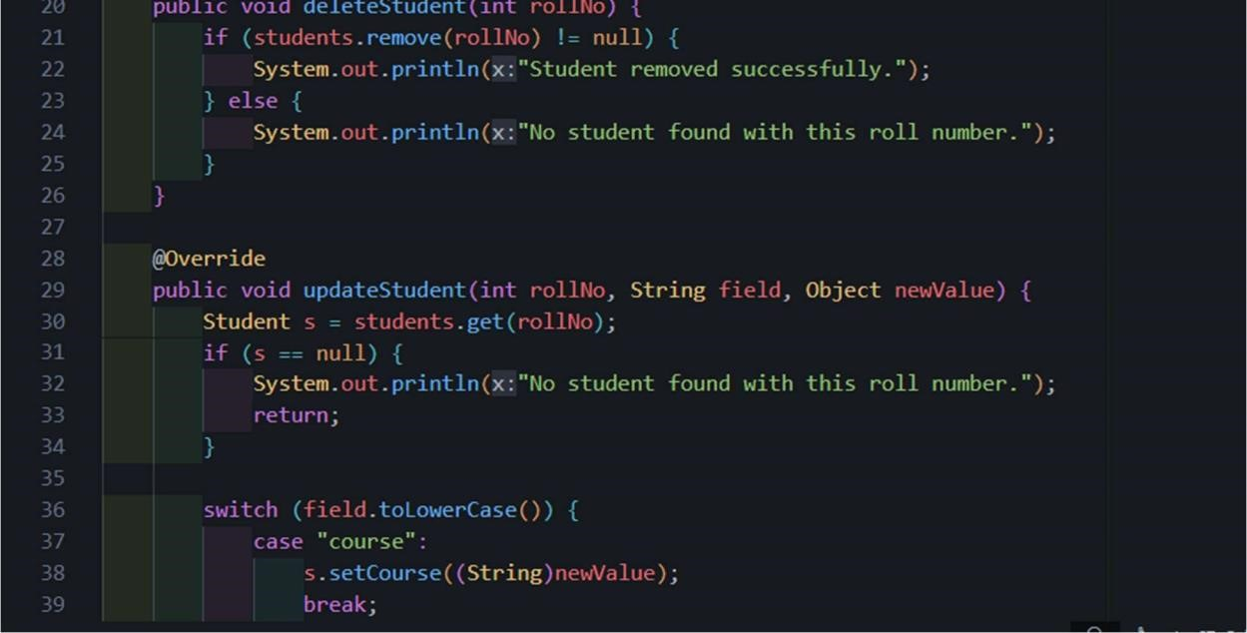
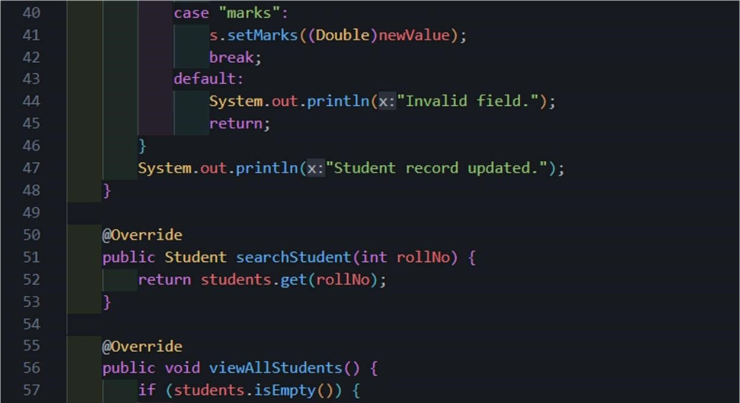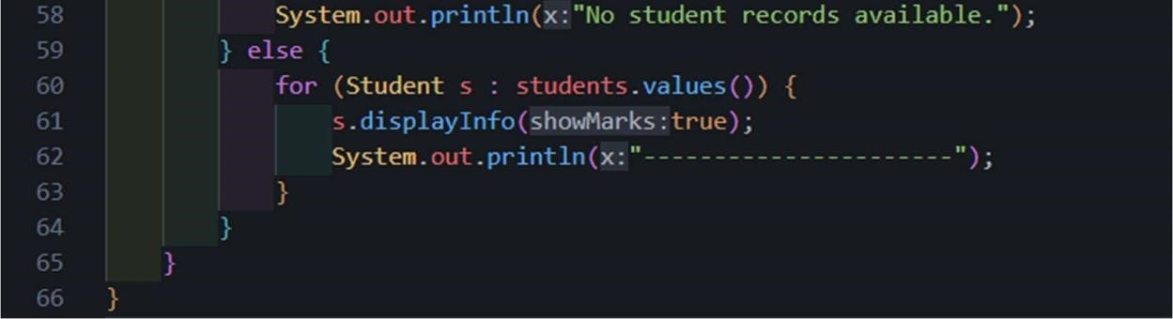

Code:
package service;

import model.Student; import java.util.HashMap;

public class StudentManager implements RecordActions { private
HashMap<Integer, Student> students = new HashMap<>();

@Override public void addStudent(Student s) { if
(students.containsKey(s.getRollNo())) {
System.out.println("Error: Student with this roll number already exists!"); } else
{ students.put(s.getRollNo(), s);
System.out.println("Student added successfully.");
}
}

@Override public void deleteStudent(int rollNo) { if
(students.remove(rollNo) != null) {
System.out.println("Student removed successfully.");
} else {
System.out.println("No student found with this roll number.");
}
}

@Override public void updateStudent(int rollNo, String field, Object newValue) { Student s = students.get(rollNo); if (s == null) {
System.out.println("No student found with this roll number.");
return;
}

switch (field.toLowerCase())
{ case "course":
s.setCourse((String)newValue);
break;
case "marks":
s.setMarks((Double)newValue);
break; default:
System.out.println("Invalid field."); return;
}
System.out.println("Student record updated.");
}

@Override public Student searchStudent(int rollNo) { return students.get(rollNo);
}

@Override public void viewAllStudents() { if
(students.isEmpty()) {
System.out.println("No student records available.");
} else { for (Student s : students.values()) {
s.displayInfo(true);
System.out.println("----------------------");
}
}
}
}

Output:
